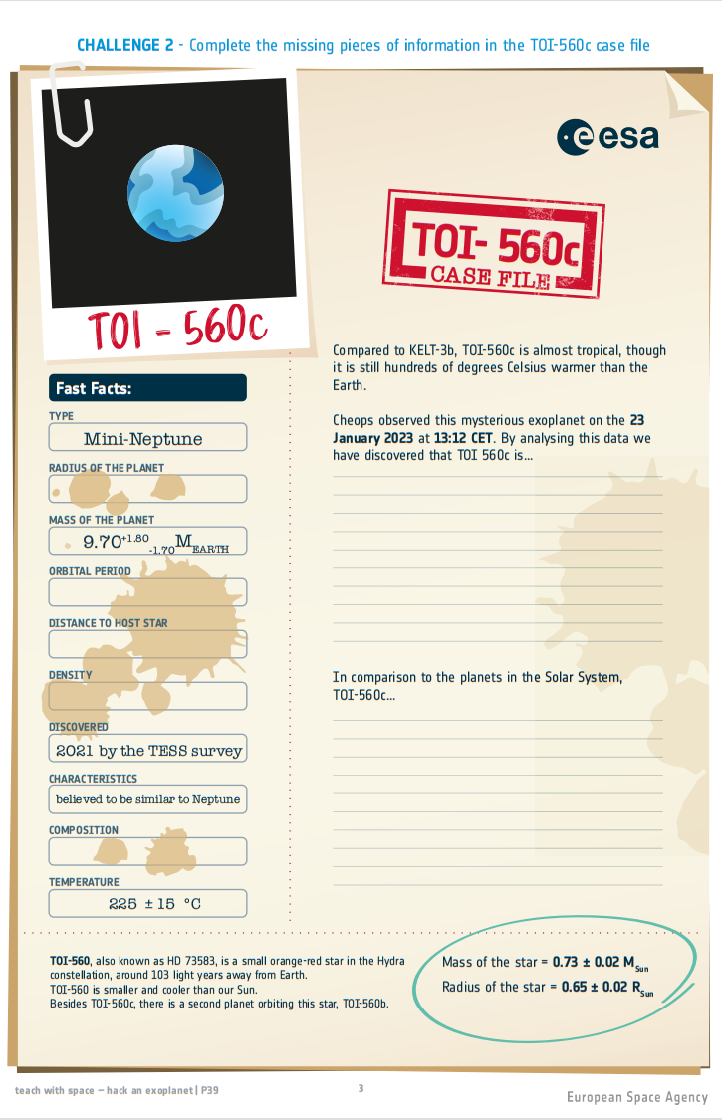

Is similar to a rocky planet of the Solar System, given its radius, mass, mean orbital distance and orbital period. TOI-560c's density is closer to Mars’ density. Moreover, due to its closeness to the host star, TOI-560, the planet is exposed to the winds the star emanates and can´t, because of them, form an atmosphere.

A planet that can’t be habitable because of its closeness to the host star, TOI-560, which proximity means a very high surface temperature and an exposure to high levels of radiation; due to this, liquid water can’t exist on the planet’s surface and the forms of life we know and love can’t survive these conditions.

Rocky

2,57 g.cm^-3

0,125ua / 1,869x10^7 km

18d 21h, 1632098s

17513,82 km