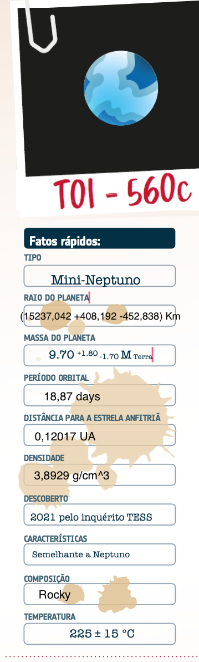

In comparison to the Planets of the Solar System, TOI-560c...
The exoplanet Toi-560c has a radius that is similar to Neptune’s. It is an exoplanet that is very close to its Sun, 0,12UA, in comparison to, for example, Mercury the first planet in our Solar system whose distance to the Sun is 0,39UA. Alike Mercury, this Exoplanet is expected to receive a lot of radiation from its Sun. Toi-560c has a density of 3,8929, alike Mars, therefore we concluded that it is a Rocky Planet. It has the second highest surface temperature if we were to rank it with the surface temperatures of the planets on our Solar System.
Cheops observed this mysterious exoplanet January 23rd 2023 at 13:12 CET. Analysing this data, we found that TOI-560c is:
Based on the density of the Exoplanet we concluded that it has a rocky nucleus. Although, based on the fact that it is similar to Neptune, it also has a gaseous component.
The Exoplanet seems to describe a circular orbit, having a small eccentricity.
Based on the calculation of the surface temperature using Stefan-Boltzmann Law, it seems like it is around 232,5ºC what can be a signal of a weak atmosphere, being close to its star also can be a sign that it doesn’t have an atmosphere since it is bombarded with solar radiation, ionizing it.
According to an Hertzsprung-Russel Diagram, its star seems to be new in comparison to the Sun, having only 0,48 +-0,19 Gyr, which means that the system is only on the beggining of life, alike the Sun on our Solar System which can be something similar to what Earth experienced in the past, making it possible candidate, something that can fall short due to its proximity to its sun.

